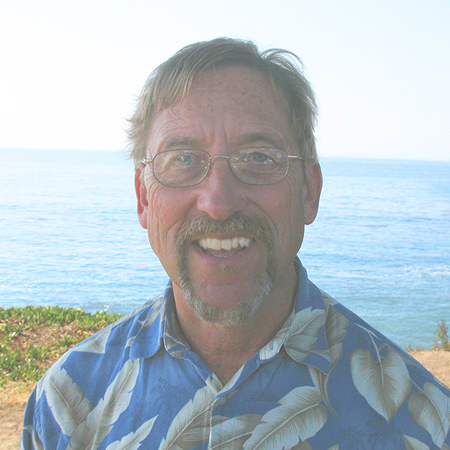
Neil F. Waldhauer
(831) 427-1529
130 Serra Court, Santa Cruz, CA 95060
neil@blondeguy.com
http://www.blondeguy.com

Platform expert for OS/2, ArcaOS and eComStation

Project Management, Troubleshooting, Software Engineering, Business and Non-profit administration, Conference organization,
Web Development and Design

For 19 years, I have run an IBM OS/2 consulting business, working mainly for large corporations with legacy systems in need of support. I have serviced and upgraded Ford assembly lines for a supplier of automation equipment, maintained the fare card system for the New York City Subway system and done a variety of tasks for smaller systems.

I work on site when necessary, but largely consult by phone, e-mail and remote administration from my office.

I serve on the board of Warpstock, a non-profit that puts on an annual international conference of OS/2 users. I serve on the board of VOICE, a Dutch non-profit, and have managed the PMMail project, a far-flung project group involving 15-20 people upgrading, testing and maintaining OS/2 software.

I created and support Suntan Special, a complex OS/2 software package that does system maintenance, installation and configuration management.

I am happy to use my diagnostic, programming and coordinating skills on worthwhile projects.

